**COMPUTER NETWORKS**

**MODALLA PRANITH REDDY 2420030158**

**LAB - 3**

**Configuration of basic switch setup using a Huawei/Cisco network switch using Cisco Packet Tracer.**

Step 1: Add one switch & two PCs to connect the switch to the PCs using a copper straight-through cable. Connect the PCs to the switch using the Fast Ethernet ports.

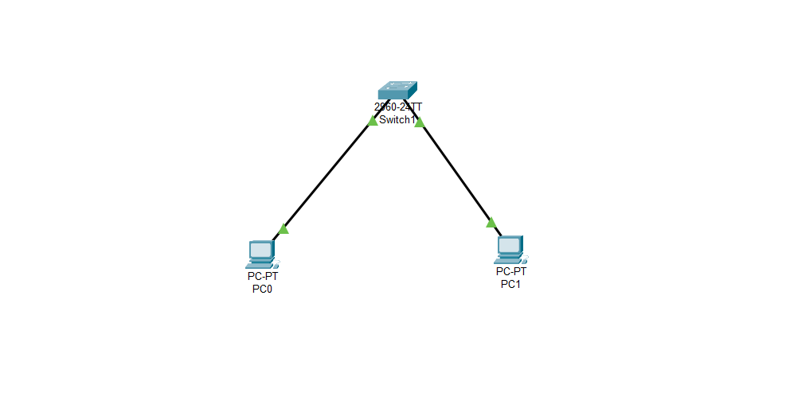

Step 2: Configuring the switch

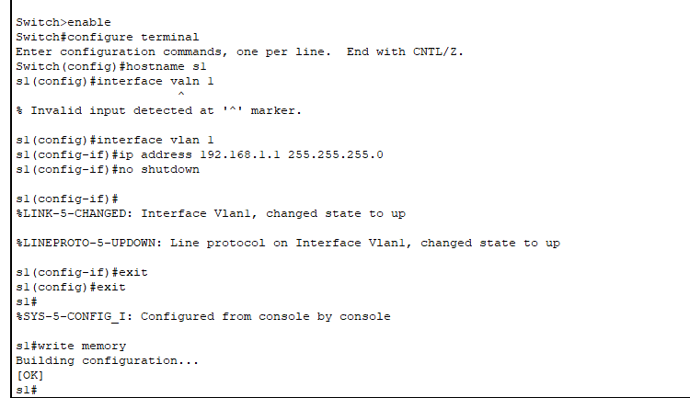

Step 3: Configuring PCs

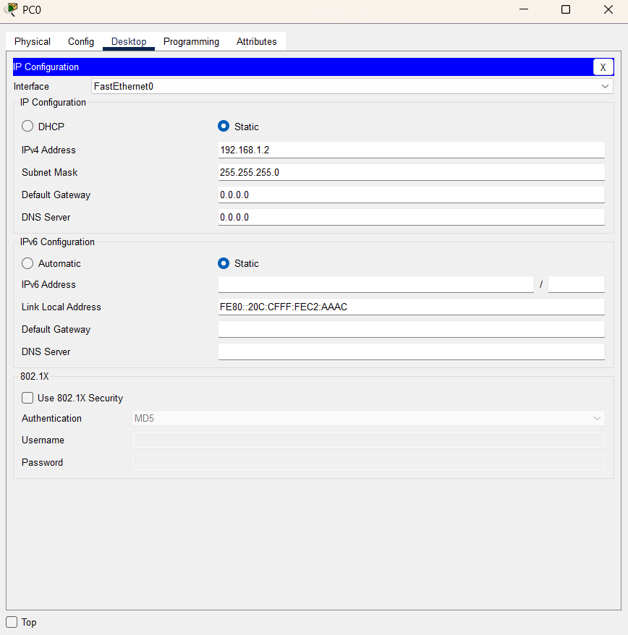

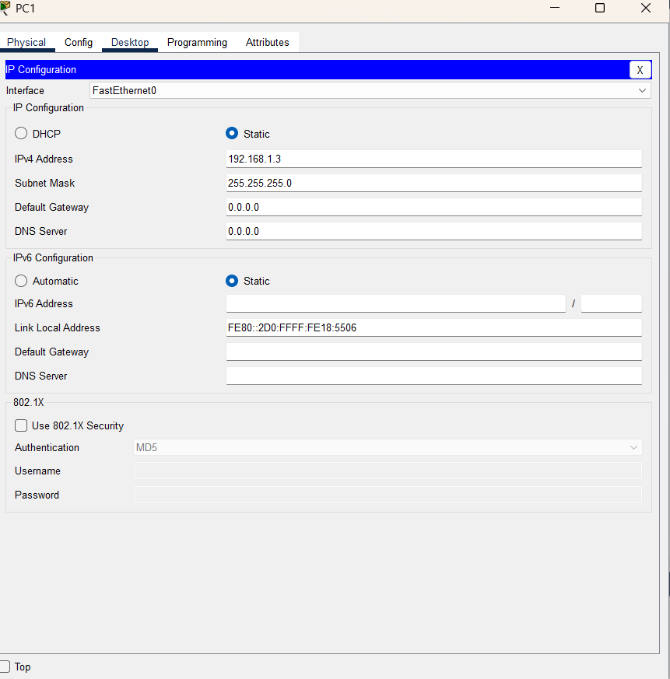

Step 4: Testing connectivity

